

SIMATS ENGINEERING

Saveetha Institute of Medical and Technical Sciences
Chennai- 602105

Student Name:G Amrutha Reg. No.:192511250
Course Code: CSA1706 Slot: B
Course Name: ARTIFFICIAL INTELLIGENCE
Course Faculty: DR.KRISHNAKUMAR KATHIRESAN
Project Title: HOUSE PRICE PREDICTION
Module Photographs: (3 photographs –Module Photo, Individual student contribution module work in the project and presentation image)
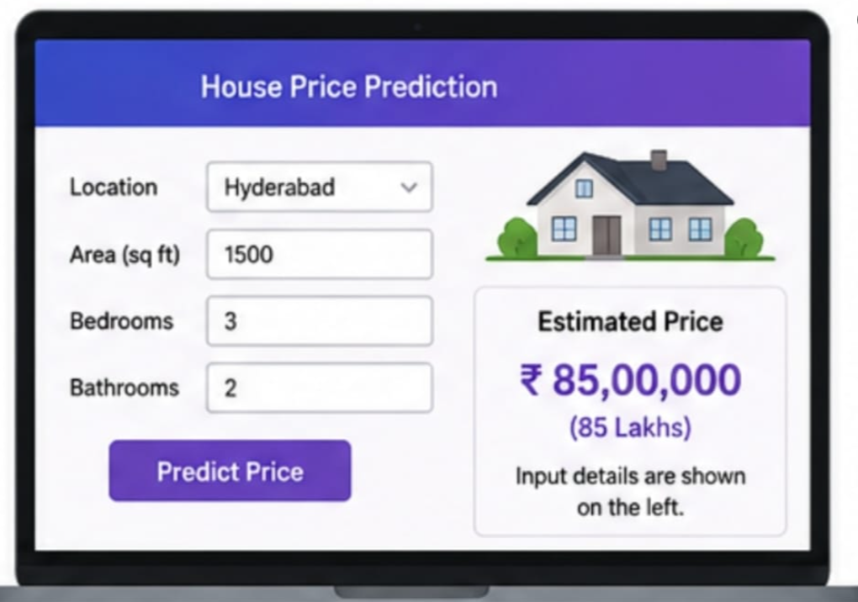
Project Description: (here you write what you did in this project (contribution) including Model Description
House Price Prediction is a machine learning project that aims to predict the selling price of a house based on various factors such as location, area, number of bedrooms, bathrooms, parking availability, house age, and other property features. The project uses historical housing data to identify patterns between property characteristics and their corresponding prices.The collected dataset is first preprocessed by handling missing values, removing unnecessary data, converting categorical variables into numerical form, and selecting relevant features. Exploratory Data Analysis (EDA) is then performed to understand the relationship between different features and house prices. Machine learning regression algorithms such as Linear Regression, Decision Tree Regression, Random Forest Regression, or Gradient Boosting can be trained using the prepared dataset. The dataset is divided into training and testing sets, and the models are evaluated using metrics such as Mean Absolute Error (MAE), Mean Squared Error (MSE), Root Mean Squared Error (RMSE), and R² score.The final system accepts the characteristics of a house as input and provides an estimated house price. This project demonstrates how machine learning can support real-estate price estimation and assist buyers, sellers, agents, and property developers in making data-driven decisions.

Student Signature Guide Signature

